Please note: This list is not inclusive of all items that may require inspection. Failure to be ready for a requested inspection may result in a re-inspection fee. In a Special Flood Hazard Area, all provisions of the municipal code and Flood-Resistant construction must be followed.
DECKS
GENERAL
- This document does not apply to decks supporting a hot tub or similar large concentrated load. An engineered drawing will be required in these instances.
- All decks require a permit except for those that are detached from the dwelling, less than 200 square feet, and less than 30” in height from the ground.
- All decks shall be constructed of materials resistant to moisture and decay.
- Lumber shall be No. 2 grade or better
- Plastic composite deck boards, stair treads, guards or handrails must be stamped in compliance with ASTM D7032 and not exceed the flame spread index of 200 when tested with ASTM E84 or UL 723 and termite resistant in accordance with ASTM D7032
- All screws, bolts, washers, nuts, and nails for use with preservative treated wood shall be hot‐dipped zinc‐coated galvanized steel, stainless steel, silicon bronze, or copper.
- In lieu of the requirements in this document, an engineer’s report showing structural equivalency may be submitted for review.
- Flashing shall be corrosion-resistant metal of nominal thickness not less than 0.019 inch or approved nonmetallic material that is compatible with the substrate of the structure and the decking materials.

FOOTINGS AND POSTS
- Decks are required to be properly anchored to the ground. Prefabricated deck footings that sit on top of the ground are not permitted to serve as the foundation for a deck.
- All footings must be a minimum 12” deep. Exact footing size to be determined by the table R507.3.1
Exception: Free standing decks that meet all of the following criteria:
- The joists bear directly on precast concrete pier blocks at grade without support by beams or posts
- The area of the deck does not exceed 200 square feet
- The walking surface is not more than 20 inches above grade at any point within 36 inches measured horizontally from the edge.
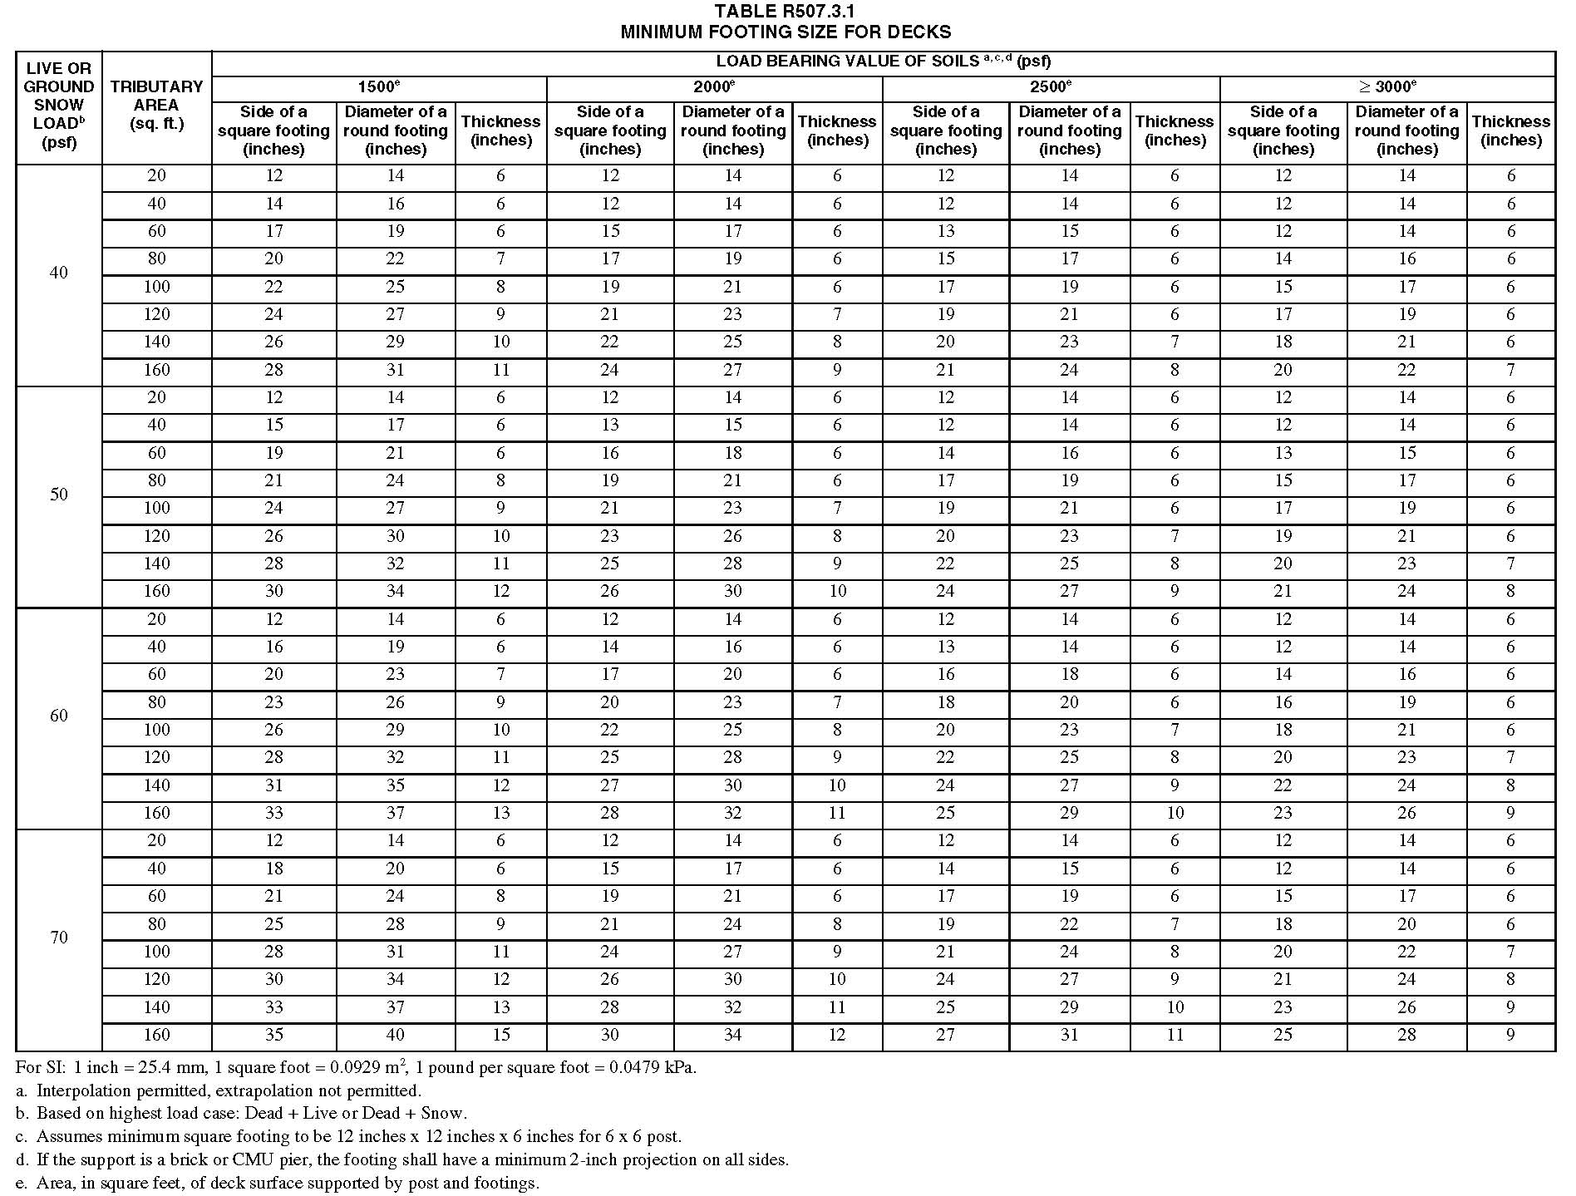

- Single-level deck post sizing: Sizing is based on height shown in Table R507.4. No deck shall exceed a height of 14’ without an engineered design.

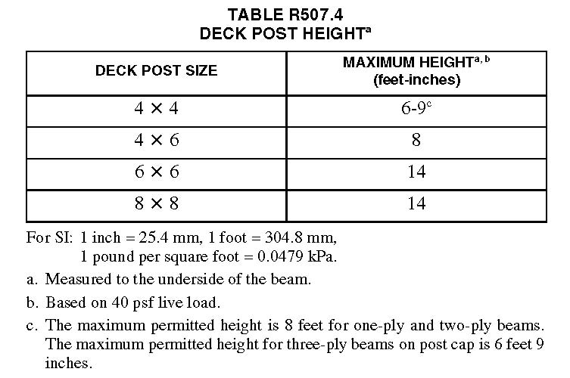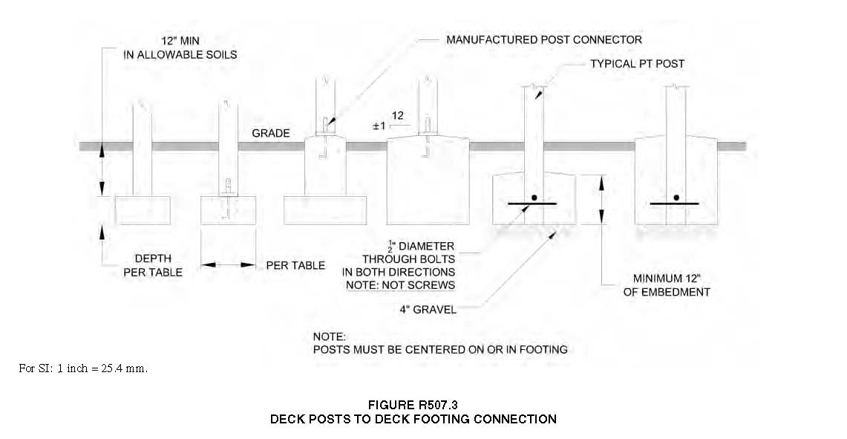
Deck Beams
- Deck Beam Spans: Decks with beams shall use Table R507.5 for sizing the beam properly:
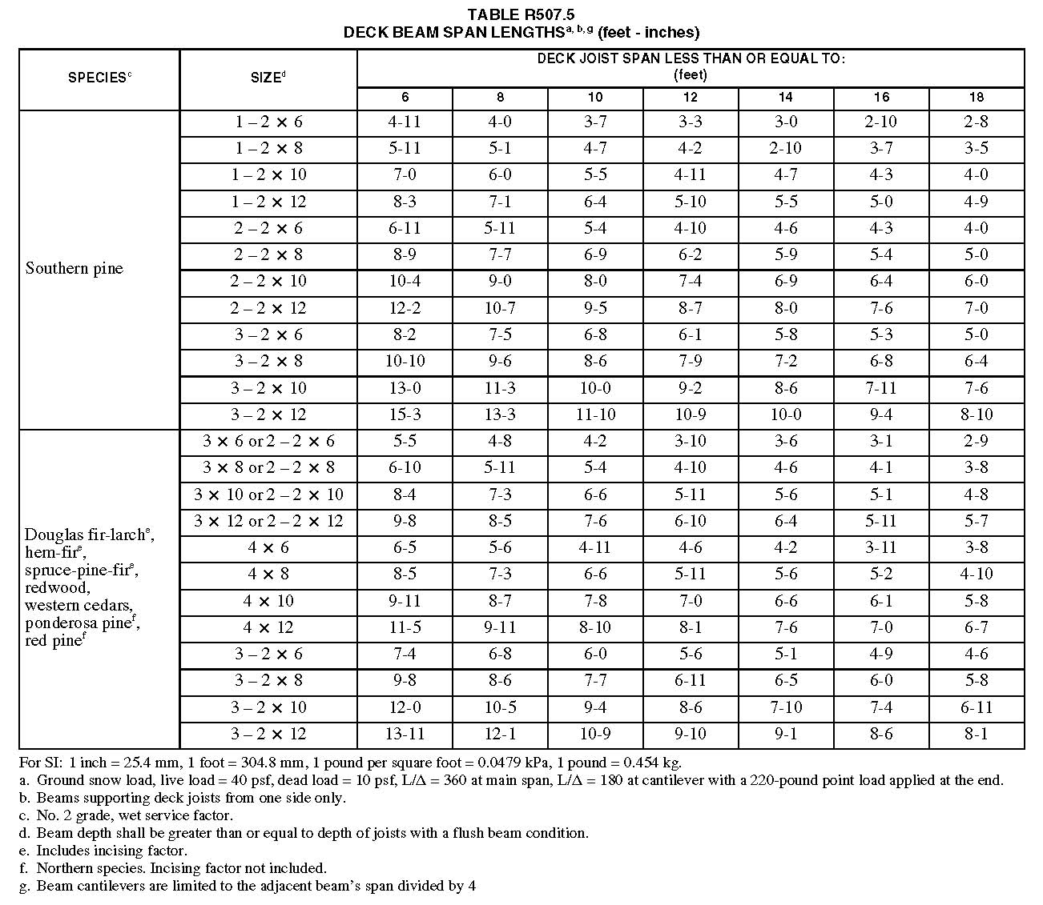
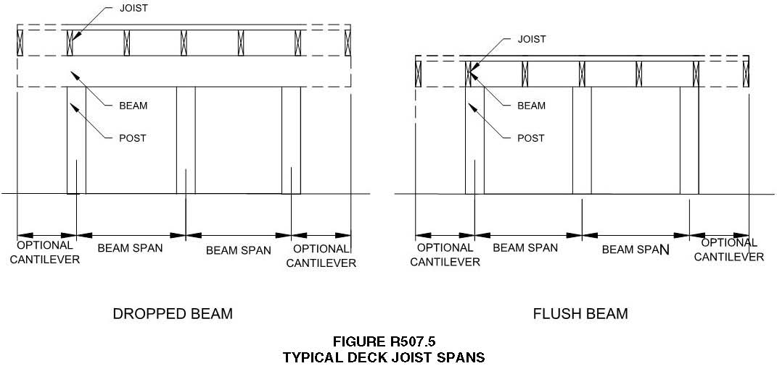
- Deck Beam Bearing: Deck beams must bear no less than 1 ½ inches of bearing on wood or metal and not less than 3 inches on concrete or masonry for the entire width of the beam. When there are multiple span beams bearing on intermediate posts each ply must have full bearing on the post matching figure 507.5.1 (1) and R507.5.1 (2) 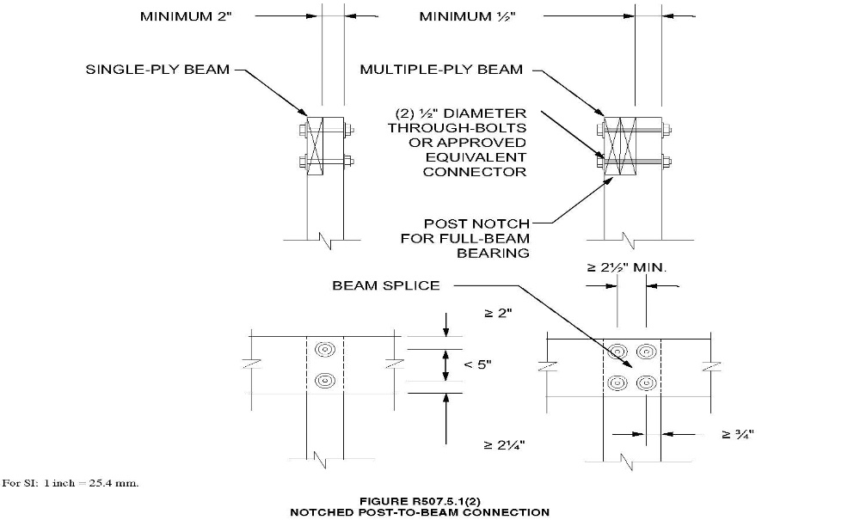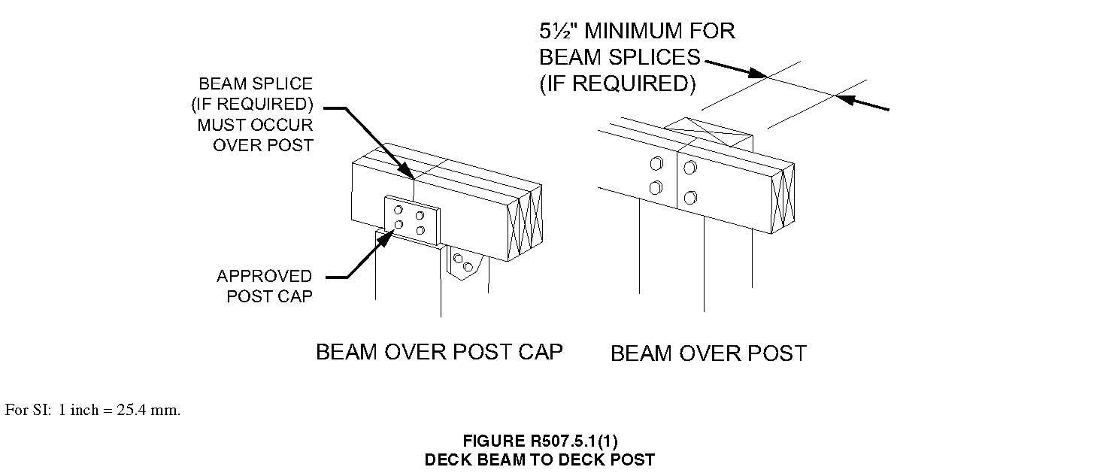

- Deck Beam Support: Deck beams shall be attached to supports in a manner capable of transferring vertical loads and resisting horizonal displacement. Manufactured post-to-beam connectors shall be sized for the post and beam sizes. Bolts shall have washers under the head and nut
Deck Joists
- Deck Joist Span: The maximum allowable spans for wood deck joists are shown in Figure R507.6 and shall be in accordance with Table R507.6.
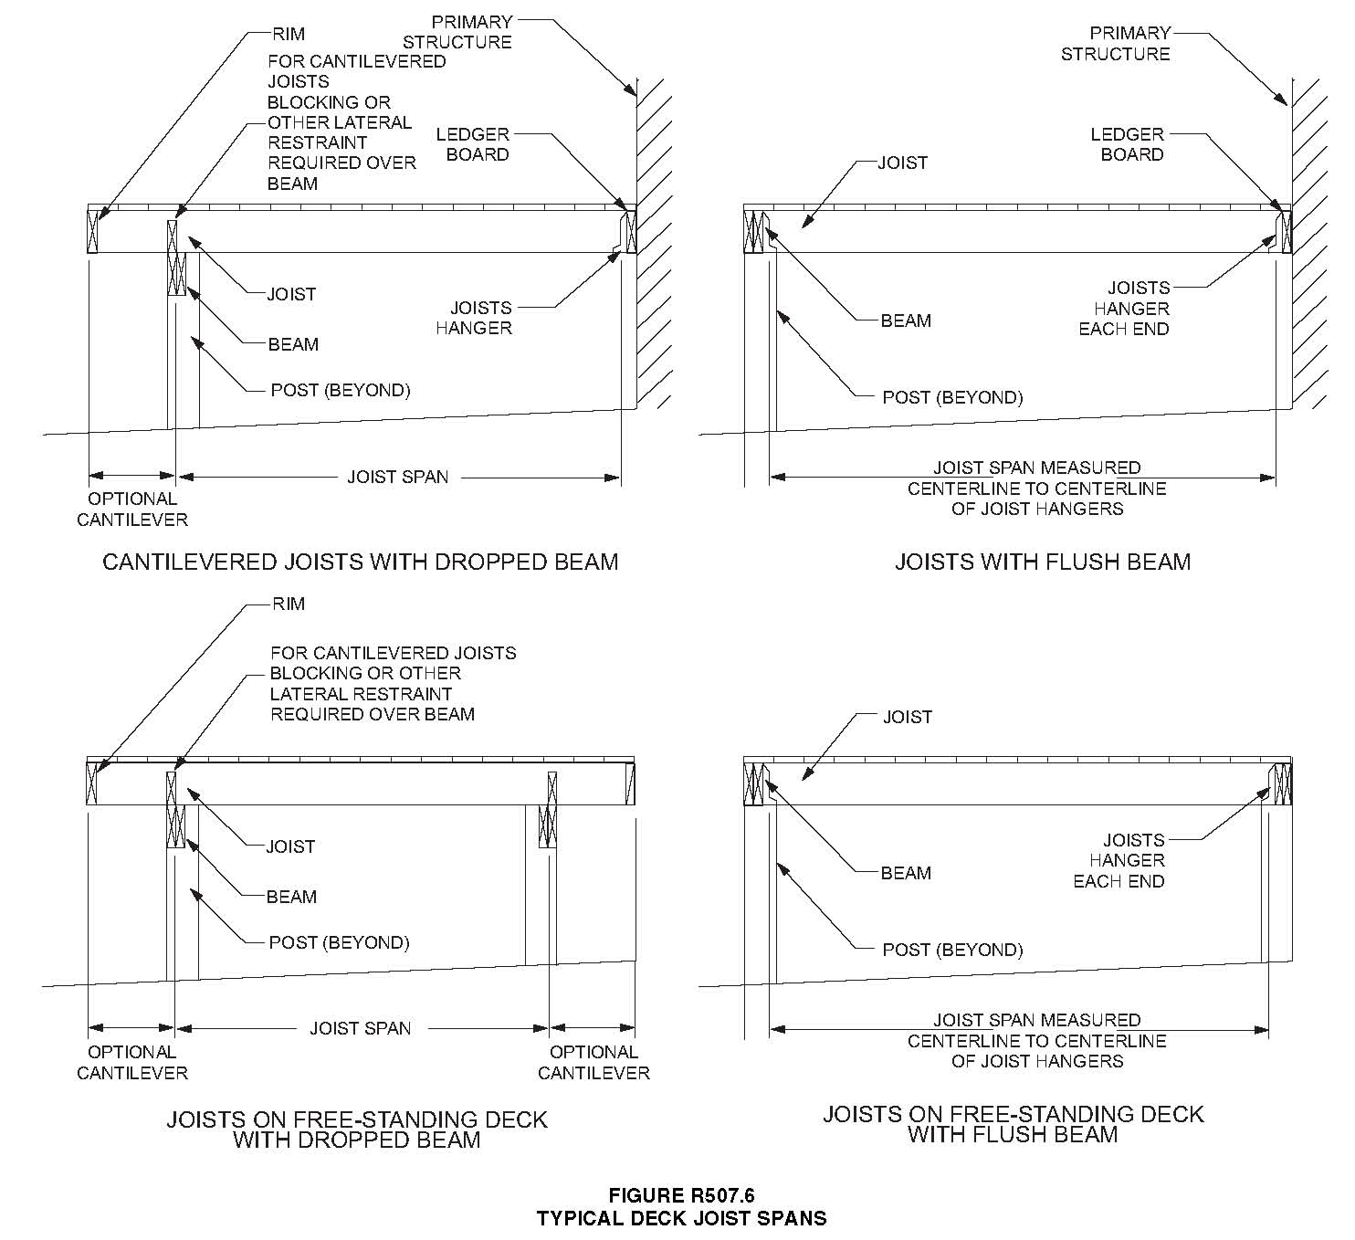
- Deck Joist Cantilevering: The maximum allowable joist cantilever shall be limited to one-fourth (1/4) of the joist span or a maximum cantilever length specified in Table R507.6, whichever is less.
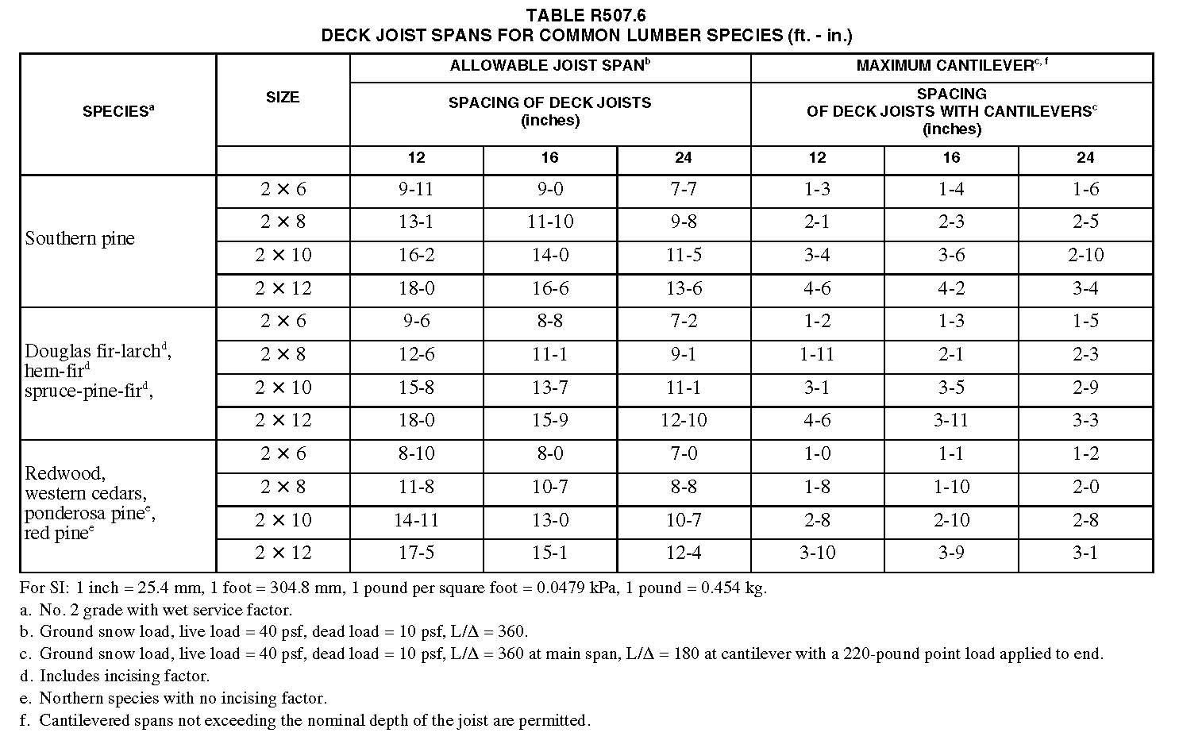
- Deck Joist Spacing: The maximum joist spacing shall be limited by the decking materials in accordance with Table R507.7
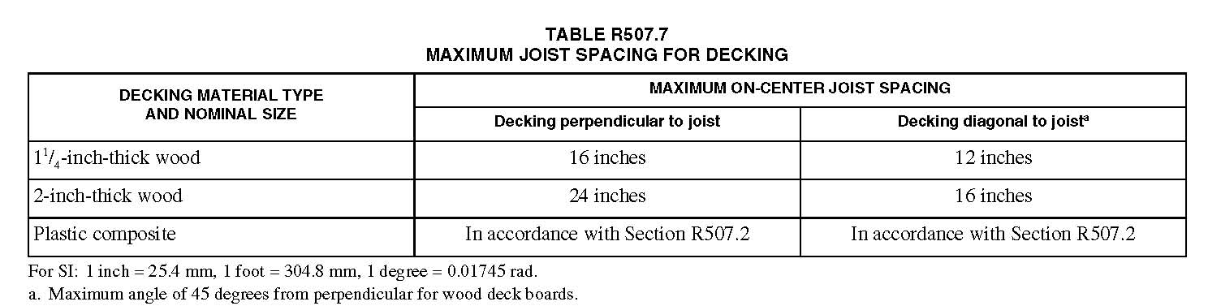
- Deck Joist Bearing: Deck joist bearing shall have no less than 1 ½ inches on wood or metal and no less than 3” on Concrete or masonry.
- Deck Joist Connection: Joists bearing on top of a multiple-ply beam or ledger shall be fastened in accordance with Table R602.3(1). Joists bearing on top of a single-ply beam or ledger shall be attached by a mechanical connector. Joist framing into the side of a beam or ledger board shall be supported by approved joist hangers.
Deck Ledgers and Attachment to House
- Deck Ledgers Details: Deck ledgers shall be a minimum 2-inch by 8-inch nominal, pressure-preservative treated southern pine, incised pressure-preservative treated hem-fir, or approved, naturally durable, No. 2 grade or better lumber. Deck ledgers shall not support concentrated loads from beams or girders. Deck ledgers shall not be supported on store or masonry veneer.
- Band Joist Details: Band joists supporting a ledger shall be a minimum 2-inch nominal solid sawn spruce pine fir or better lumber or a minimum 1 inch by 9 ½ inch dimensional Douglas fir or better laminated veneer lumber. Band joists must bear fully on the primary structure capable of supporting all required loads.
- Ledgers to Band Joist Details (Bolts and Lag Screws): Fasteners used in deck ledger connections in accordance with Table R507.9.1.3(1) shall be hot-dipped galvanized or stainless steel and shall be installed in accordance with Table R507.9.1.3(2) and Figures R507.9.1.3(1) and R507.9.1.3(2)
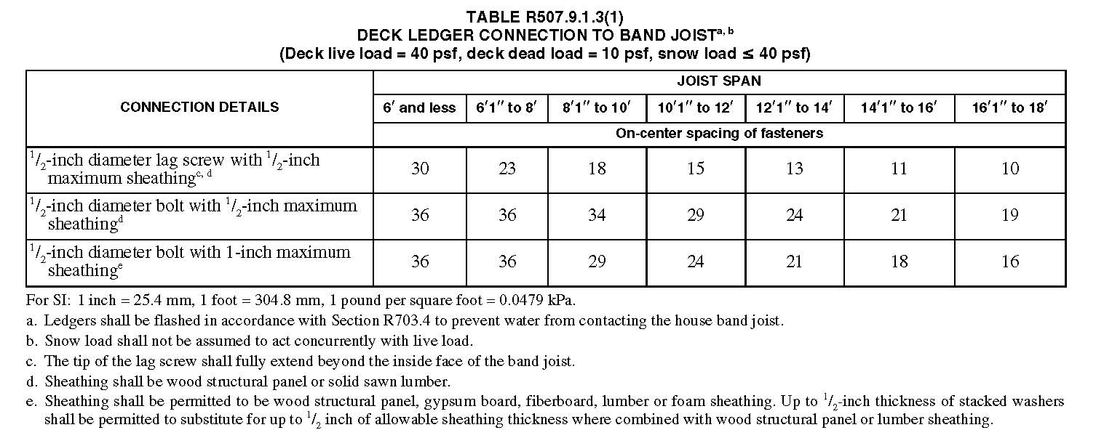
- Ledgers to Band Joist Details: Fasteners used in deck ledger connections in accordance with Table R507.9.1.3(1) shall be hot-dipped galvanized or stainless steel and shall be installed in accordance with Table R507.9.1.3(2) and Figures R507.9.1.3(1) and R507.9.1.3(2)
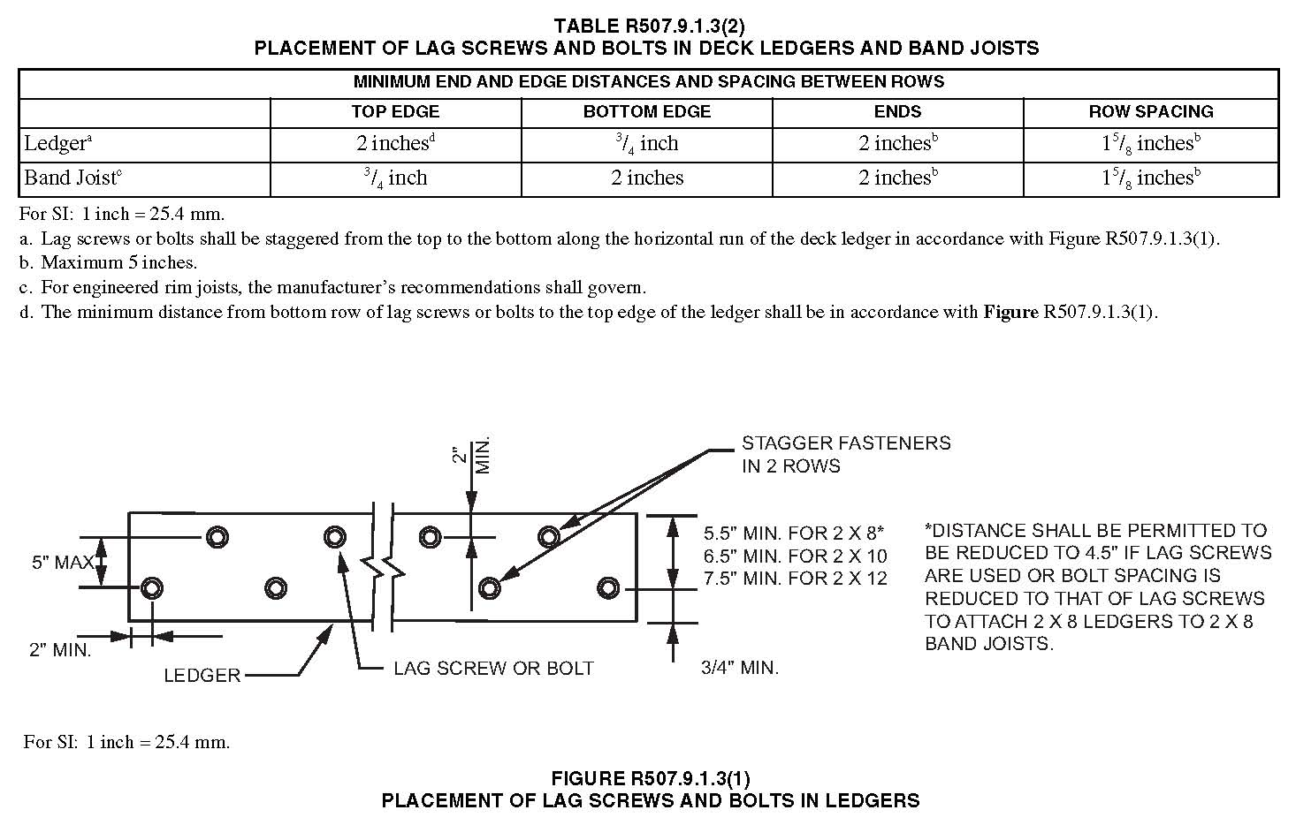

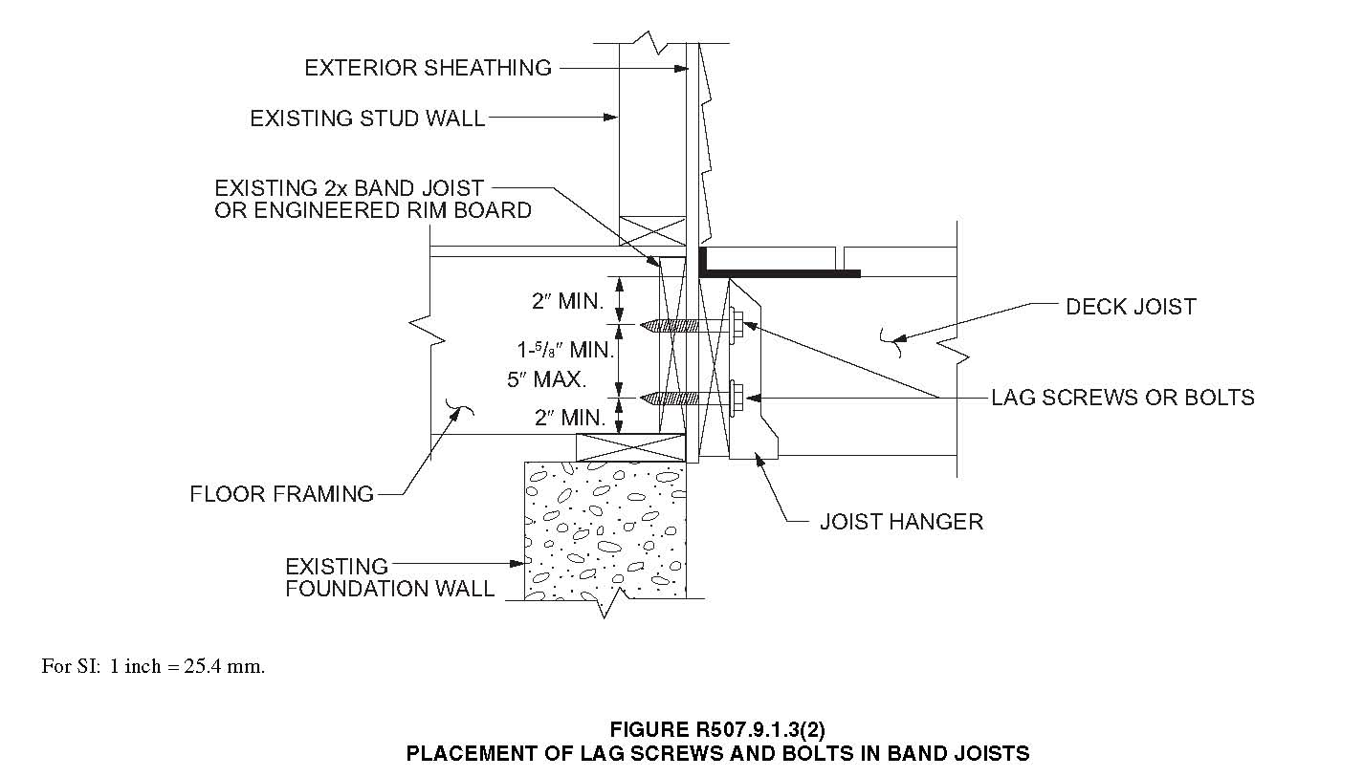

- Lateral Connections: Lateral loads shall be transferred to the ground or to a structure capable of transmitting them to the ground. Where the lateral load connection is provided in accordance with Figure R507.9.2(1), hold down tension devices shall be installed in not less than two locations per deck within 24 inches of each end of the deck. Each device shall have an allowance stress design capacity of not less than 1,500 pounds. Where the lateral location connections are provided in accordance with figure R507.9.2(2), the hold down tension devices shall be installed in not less than four locations per deck, and each device shall have an allowable stress deigns capacity of not less than 750 pounds.
