Please note: This list is not inclusive of all items that may require inspection. Failure to be ready for a requested inspection may result in a re‐inspection fee. In a Special Flood Hazard Area, all provisions of the municipal code and Flood‐Resistant construction must be followed.

FINAL

EXTERIOR

- House numbers plainly legible and visible from the street, minimum 4”. (R319.1)
- Wood siding, sheathing and wall framing has a minimum clearance of 6” from the ground or 2” from concrete. (R317.1)
- Grade slopes a minimum of 6” away from the building within the first 10’. (R401.3)
- Carports open on at least two sides. (R309.2)

GARAGE

- Garage ceiling beneath habitable rooms shall be installed perpendicular to the ceiling framing and be of not less than 5/8” Type X gypsum board or equivalent.
- Ducts in garages which penetrate the walls or ceilings separating the dwelling from the garage shall be constructed of a minimum No. 26 gage sheet metal and can have no openings into the garage. (R302.5)
- An opening from garage directly into a room used for sleeping purposes is not permitted. (R302.5.1)
- Door between garage and residence is solid wood, not less than 1 3/8” in thickness or honeycomb core steel door not less than 1 3/8” thick, or 20 minute fire rated door, and equipped with a self‐closing device. (R302.5.1)
- Walls separating the residence and garage shall be not less than 1/2” gypsum board or equivalent applied to the garage side.

DECKS

- All deck material is treated or naturally resistant to decay. (R317)
- Fasteners and hardware for pressure preservative and fire‐retardant‐treated wood shall be of hot‐dipped galvanized steel, stainless steel, silicon bronze or copper. (R317.3)
- Bottom of footings are a minimum 12” below grade for freeze protection. (R403.1.4)

- Deck is properly attached to primary structure. Attachment shall not be accomplished by the use of toenails or nails subject to withdrawal.(R507.1) Lag screws or bolts in the deck ledger shall be placed in accordance with Table 507.2.1:
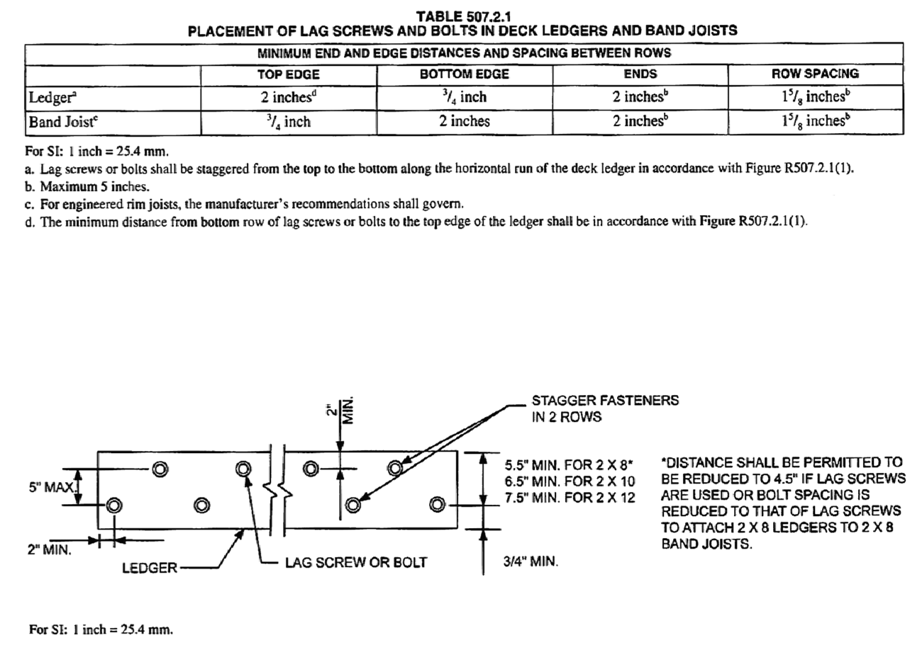

GUARDS AND HANDRAILS

- Guards required at the open side of walking surfaces, including stairs, ramps and landings that are located more than 30” above grade. (R312.1.1)
- Guards do not have openings which allow passage of a 4” sphere. (R312.1.3)
- Triangle formed by riser, tread and bottom element of guardrail does not allow passage of a 6” sphere. (R312.1.3)
- Required guards shall not be less than 36” in height above adjacent walking surface. (R312.1.2)

- Handrail required at stairs with 4 or more risers. (R311.7.8)
- Handrail height shall not be less than 34” and not more than 38”. (R311.7.8.1)
- Handrail shall be graspable and of approved dimensions. (R311.7.8.3)
- Handrails are continuous for the full length of the stairway. (R311.7.8.2)
- Handrail ends shall be returned or terminate in newel post or safety terminal. (R311.7.8.2)
- Stairways shall not be less than 36” in clear width at all points above the permitted handrail height. (R311.7.1)
- Glazing adjacent to the landing at the bottom of a stairway that is less than 36” above the landing and within 60” horizontally of the bottom tread is considered a hazardous location and must be tempered. (R308.4.7)

ATTIC

- Attic accesses required to areas exceeding 30 square feet and have a vertical height of 30” or greater.
- Rough framed opening shall not be less than 22”x30”. (R807.1)
- Insulation does not block the free flow of air at eave or cornice vents. Minimum 1” space is provided between the insulation and roof sheathing. (R806.3)
- All insulation requirements have been met. (See Energy Inspection checklist)
- All plumbing vents and mechanical vents are properly vented to the exterior.

CRAWLSPACE

- Floor insulation having an R‐value of R‐19 or greater is installed to maintain permanent contact with the underside of the subfloor decking.
- All debris removed from the crawl space. (R408.5)
- Crawlspace venting requirements/vapor barrier requirements are properly met. (See Framing Inspection checklist)

SMOKE AND CARBON MONOXIDE ALARMS

- Alarms are interconnected in such a manner that the actuation of one alarm will activate all of the alarms. (R314.4)
- An approved carbon monoxide alarm is installed in dwelling unit with fuel fired appliances and in dwelling units that have an attached garage. (R315.1)

- Smoke alarms shall be located in each sleeping room, outside each separate sleeping area, basements, and habitable attics. (R314.4)
- Carbon monoxide detector is a permanent fixture and installed outside of each separate sleeping area in the immediate vicinity of the bedrooms. (R315.1)

WINDOWS AND GLAZING

- Basements, habitable attics, and every sleeping room have at least one operable emergency escape and rescue opening. (R310.1)
- Emergency egress opening located in each sleeping room. (R310.1)
- Emergency egress openings do not have a sill height greater than 44” above the finished floor. (R310.1)
- All emergency egress openings have a minimum net clear opening of 5.7 square feet. (R310.1.1)
- Emergency egress opening minimum net clear opening height shall be 24”. (R310.1.2)
- Emergency egress opening minimum net clear width shall be 20”. (R310.1.3)
- Emergency escape and rescue openings shall be operation from the inside of the room without the use of keys, tools, or special knowledge. (R310.1.4)
- All tempered glazing is installed in required locations. (See Framing inspection checklist)
- Window fall protection is provided as required for windows whose sill is located higher than 72” off of finished grade on the exterior and the height of window sill on interior is closer than 24” to finish floor. (R312.2)

*In order to be granted a Certificate of Occupancy, the City of Cleveland requires that permanent erosion control be in place at the time of the final inspection.
*A blower door test and duct tightness test must be passed before a Certificate of Occupancy can be issued.

