Please note: This list is not inclusive of all items that may require inspection. Failure to be ready for a requested inspection may result in a re‐inspection fee. In a Special Flood Hazard Area, all provisions of the municipal code and Flood‐Resistant construction must be followed.

MECHANICAL ROUGH IN

GENERAL

- Fuel burning appliances cannot be installed in sleeping rooms, bathrooms, toilet rooms, storage closets, or in a space that opens into such rooms or spaces unless they are direct vent or listed for use within a living space. (G2406.1) (G2406.2)
- Heat producing equipment installed shall maintain clearances to combustibles as required by the listing of the appliance. (M1402.2) (M1306.1)
- Minimum working space around furnace or air handler is 3”.

UNDER FLOOR/ATTICS

- Equipment and appliances installed in an underfloor area suspended from the floor shall have a minimum clearance of 6” above grade or installed on a slab extending 3” above adjoining grade. (M1305.1.4.1)
- Equipment installed in attics shall be provided with an opening and a clear passageway large enough to remove the largest appliance, but not less than 30” high and 22” wide, not more than 20’ long from the opening to the appliance. The passageway shall have continuous solid flooring not less than 24” wide. A level service space at least 30” deep and 30” wide shall be present along all sides of the appliance where access is required. Exceptions: The passageway is not required when the appliance can be serviced from the attic access opening. Where the passageway is unobstructed and not less than 6’ high and 22” wide, the passageway can extend to not more than 50’ long.

GARAGE

- When equipment which has a flame, generates a spark, or uses a glowing ignition source is open to the space in which it is installed, it shall be elevated such that the source of ignition is at least 18” above the floor. Exception: Elevation of the ignition source is not required for appliances that are listed as flammable vapor ignition resistant.

- Ducts which penetrate a wall or ceiling separating the garage from the dwelling are 26 gauge with no openings to the garage. (R302.5.2)
- Appliances shall not be installed in a location subject to vehicle damage except where protected by approved barriers, such as a bollard embedded in concrete. (M1307.3.1)

CONDENSATE

- Condensate from all cooling coils or evaporators shall be conveyed from the drain pan outlet to an approved place of disposal. Such piping shall maintain a minimum horizontal slop in the direction of discharge of not less than 1/8 unit vertical in 12 units horizontal (1% slope). Condensate shall not discharge into a street, alley, or other area where it would cause a nuisance (this includes areas where erosion along the foundation or underneath the appliance might occur). (M1411.3)
- Condensate piping must be a minimum ¾” pipe. (M1411.3.2)
- Condensate shall not have a direct connection to the building drain/waste/vent system. If the condensate is connected to the DWV system using an indirect connection, the connection must be trapped and the trap must be prevented from drying out.
- A secondary means of protection from condensate is necessary in addition to the primary condensate disposal, where damage to building components can occur from overflow or stoppage of condensate piping. This can be achieved through a condensate overflow shutoff switch installed in the pan, or the outlet of the pan. (M1411.3.1)

DUCTING

- Duct to ground minimum 4” clearance. (M1601.4.7)
- Duct in or under concrete encased in a minimum 2” of concrete. (M1601.1.2)
- Round ducts have crimped joints lapped minimum 1” and fastened with (3) sheet‐metal screws or rivets equally spaced around the joint. (M1601.4.1)
- Joints, seams, and fittings of ducts sealed with mastic or other approved means. (M1601.4.1)
- Flex duct supported per manufacturer’s specifications, with no harsh bends or kinks in the run. (M1601.4.3)
- Flexible ducts labeled as “Flexible Air Ducts” shall not be limited in length. Flexible ducts labeled as “Flexible Air Connectors” shall be limited to 14’ in length. (IMC 603.6.1.1) (IMC 603.6.2.1)
- Metal duct minimum support every 10’. (M1601.4.3)

- Return air cannot be taken from bathroom, kitchen, toilet room, mechanical room, closet, furnace room, other dwelling unit, or garage. (M1602.2)
- Return air inlets cannot be located within 10’ of any fuel burning appliance, fire box, or draft hood located in the same space. (M1602.2)
- Building framing cavities shall not be used as air ducts. (IECC 403.2.3)

VENTS AND CONNECTORS

- Where two gas appliances are vented through a common vent connector, it is equal to the largest connector plus 50% of the smaller flue outlet and not less than the combined area of the flue outlets for which it acts as a common connector. (G2427.10.3.4)
- Vent connector clearances to combustibles per manufacturer’s listing or performance standards. (M1803.3.4) (M1306.1) (G2427.7.8)
- Single wall vents cannot penetrate a wall, floor, or ceiling without a listed pass through assemble, except for gast vents
– exterior combustible walls only – with a “ventilated metal thimble”. (M1801.1) (G2427.7.7)
- Vent terminations installed per the manufacturer’s listing. (M1804.2) (G2427.6.3)
- Bathroom exhaust fans must terminate to the exterior and cannot terminate in the attic.
- Exhaust vent terminations for mechanical draft and direct venting must be the correct distance from a door, operable window, or a gravity air inlet into a building. (M1804.2.6) (G2427l.8)
- Gas vent piping has a minimum ¼” /foot upward slope.
- Gas vent terminations shall be proper height from roof (See Attached Figure G2427.6.3 on next page). Gas vents greater than 12” shall terminate 2’ above and 10’ away from roof. (G2427.6.3)
- Where vents extending into an attic pass through insulated assemblies, an insulation shield of 26 gage sleeve not less than 2” above the insulation, secured in place and shall be installed to provide clearance between the vent and the combustible insulation materials, specified by the vent manufacturer. (G2426.4)

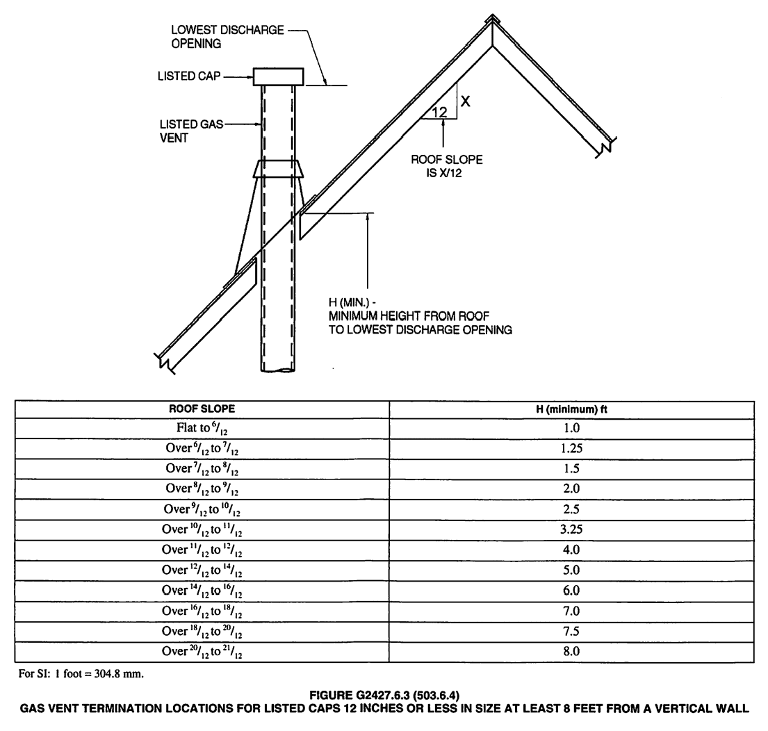

CLOTHES DRYERS

- Clothes dryer exhaust ducts of metal with smooth interior surfaces, with joints running in the direction of air flow. (M1502.4) (G2439.5)
- Protective shield steel plates of .062 thickness where nails or screws are likely to penetrate duct, including at framing members < 1 ¼” between duct and finished face of framing member. (M1502.5) (G2439.5.3)
- Screws or fasteners used to join ducts must not protrude more than 1/8” into the inside of the duct.. (M1502.4.2)
- Duct connector 4” minimum or appliance outlet size. (M1502.4.1) (G2439.5)
- Dryer duct must not exceed 35’ or the maximum length specified by the dryer manufacturer’s installation instructions. The following table shall be used to determine the equivalent lenth of a fitting, unless appliance manufacturer’s instructions say otherwise (M1502.4.4):
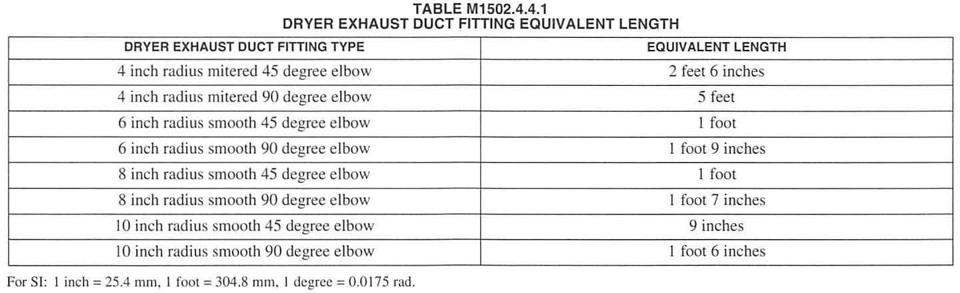

- Exterior termination is backdraft dampered with no screens, and 3’ minimum away from any openings into building. (M1502.3) (G2439.3)
- Clothes dryer ducting concealed in construction must be labeled with the total equivalent length. Label shall be located within 6’ of the exhaust connection. (M1502.4.6)
- If dryer is not installed at time of occupancy, exhaust duct shall be capped at the location of the future dryer. (M1502.4.6) (G2439.5.7)
- Gas dryer shutoff valve installed immediately ahead of connector and in the same room. (G2422.1.2.4)

AIR CONDITIONING

- Refrigerant lines shall be insulated to R‐4. IRC M1411.5
- Condenser shall be mounted on a minimum 3” concrete pad.

- All exterior wall penetrations shall be sealed.

