Please note: This list is not inclusive of all items that may require inspection. Failure to be ready for a requested inspection may result in a re‐inspection fee. In a Special Flood Hazard Area, all provisions of the municipal code and Flood‐Resistant construction must be followed

PLUMBING

UNDERGROUND

Sewer

The building sewer shall be tested before concealment by insertion of a test plug at the point of connection with the public sewer and filling the building sewer with water, testing with not less than a 10’ head of water and be able to maintain such pressure for 15 minutes. The test must be on at the time of inspection. (P2503.2) (P2503.4)
- Minimum 1/8” per foot slope when pipe size is 3” diameter or greater. (P3005.3)
- All fittings shall be properly primed and glued. (P3003)
- A cleanout is required near the junction of the building drain and building sewer. It shall be either inside or outside the building wall, at floor level or finish grade. An approved two‐way cleanout shall be permitted to serve as the cleanout for the building drain and sewer. A cleanout at this junction is not required where a cleanout on a 3” or larger diameter soil stack is located within 10’ of the developed length of the drain and sewer junction. (P3005.2.7)
- Additional cleanouts shall be installed as needed. A cleanout is required every 100’ of developed sewer length, and at any change of direction greater than 45 degrees. (P3005.2)
- If the sewer is located under a driveway or parking surface, the pipe must be 36” deep and filled with an approved loose fill, tamped every 6” to protect the pipe. If the 36” depth cannot be achieved, the pipe must be protected with a concrete cover over the trench, and the sewer pipe must be sleeved with a pipe 2 sizes larger to prevent direct contact with the concrete. (P2603.4, IPC Protection of Piping, and City requirements)
- Sewer pipe must be bedded with compacted earth, sand, fine gravel, or similar granular material to support the pipe for the full length. (P2604.1)
- Backfill over pipe shall be free from large rocks, broken concrete, or similar until the pipe is covered by not less than 12” of earth, sand, or fine gravel placed in 6” layers and tamped.
- Building sewer shall be sized appropriately, but shall not be smaller than 3” when a water closet is served.

- Sewer Material: The building sewer shall be of a material approved by the code. SDR 35 (green pipe) is allowed when the water line and sewer line are separated by 5’ of earth horizontally. When sewer and water line are placed in the same trench, the pipe must be of PVC schedule 40 or similar as allowed by code.
- The sewer shall be protected from frost, and shall never be less than 6” below finish grade. For sewer depth requirements in relation to water service piping, see Water Service requirements section.

Water Service

Water service lines shall be tested before concealment with water at operating pressure, or for pipes other than plastic pipe, a 50 psi air test. Air testing of plastic pipe is not allowed. The test must be on at the time of inspection. (P2503.2) (P2503.7) This department has contacted ICC for a ruling on air testing PEX, and ICC ruled that it is a plastic pipe and therefore cannot be tested with air.
- Water service line shall be sized appropriately, but not less than ¾” diameter. (P2903.7)
- Piping shall be supported for the entire length of its run. (P2605)
- A pressure regulator and shut off valve is required to be installed before the water service line connects to the water distribution system of the building, and must be readily accessible. (P2903.3.1)
- Based on local frost depth, the underground water service line shall be at least 12” deep for its entire run. (P2603.5)
- The water service line and sewer are allowed to be located in the same trench when the sewer pipe is of a material that is approved for use under a building slab (ex. PVC schedule 40) (P2905.4.2), and the sewer must be a minimum of 12” below the water line. Otherwise, the water line and sewer must maintain 5’ of horizontal separation distance.
- When a water service line crosses a sewer line perpendicularly, no separation is required if the water service line is sleeved 5’ in each direction from the center line of the sewer pipe.

Water Distribution and Drain/Waste/Vent system (DWV)

The DWV system shall be tested before concealment with no less than a 10’ head test of water for 15 minutes, or for piping other than plastic, a 5psi air test. The test must be on at the time of inspection. (P2503.2) (P2503.5)
- Water distribution lines shall be tested before concealment with water at operating pressure, or for pipes other than plastic pipe, a 50 psi air test. Air testing of plastic pipe is not allowed. The test must be on at the time of

inspection. (P2503.2) (P2503.7) This department has contacted ICC for a ruling on air testing PEX, and ICC ruled that it is a plastic pipe and therefore cannot be tested with air.
- Minimum ¼” per foot slope when pipe size is 2‐1/2” diameter or less; minimum 1/8” per foot slope when pipe size is 3” diameter or greater. (P3005.3)
- Pipes through foundation walls shall be sleeved with a pipe two (2) sizes larger. (P2603.4)
- No piping to pass through footings without proper provisions made to protect the piping and to insure the footing is structurally sufficient to span the pipe. (P2603.4, Code and Commentary)
- DWV pipes and water distribution piping passing through concrete slab shall be protected by sheathing, wrapping, or other means to protect from corrosion and to allow expansion and contraction of the material. (P2603.3)

ABOVE GROUND

DWV

The DWV system shall be tested at time of Rough‐In Inspection with water filled to the top of the highest vent in the system, or for piping other than plastic, a 5psi air test. (P2503.2) (P2503.5)
- Pipes are to be protected with shield plates that extend not less than 2” above sole plates and below top plates, when the pipe is located within 1‐1/2”of the face of the stud. (P2603.1)
- Pipes are to be properly supported to ensure alignment, prevent sagging, and allow for expansion and contraction. (P2605.1)
- Every trap and trapped fixture shall be properly vented. No “s” traps are allowed. (P3101.2.1)
- Traps installed in location prone to drying out shall be fitted with a trap primer, or shall be of the deep seal design. (P3201.2)
- The vent system serving each building drain shall have at least one vent pipe that extends to the outdoors. This vent shall be a dry vent that connects to the building drain. (P3102.1) (P3102.2)
- Vents and branch vent pipes shall have proper fall to allow moisture and condensate to drain back to the waste pipe. (P3104.2)
- An open vent terminal from a drainage system shall not be located less than 4’ directly beneath any door, operable window, or other air intake of the building, nor shall any vent be within 10’ horizontally of opening. Vent terminals shall not terminate under the overhang of a structure with soffit vents. (P3103.5) (P3103.6)
- Horizontal vent pipes shall be not less than 6” above the flood level rim of the highest fixture served. (P3104.5)

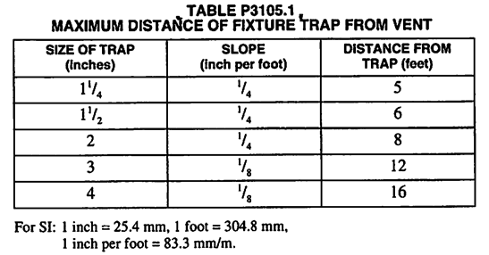
- Maximum distance from a fixture “p” trap to the vent should comply with the following table:
- Horizontal wet vents are permitted for up to two bathroom groups located on the same floor level. The wet vents shall serve as the fixture vent, and each fixture shall connect independently to the horizontal wet vent. The horizontal wet vent system is required to connect to a dry‐vent terminating to the outdoors. Not more than one wet‐vented fixture shall discharge upstream of the dry‐vented fixture drain connection. (P3108.1) (P3108.2) (P3108.2.1) Wet vent pipe sizes shall comply with the following table:
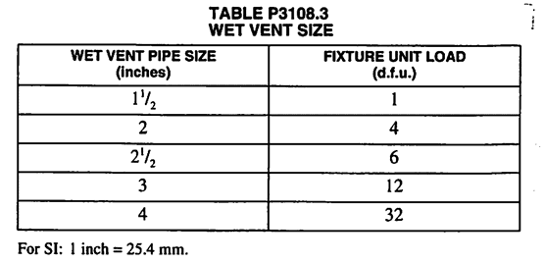
- Air admittance valves are permitted for individual vents, branch vents, circuit vents, and stack vents for fixtures that are on the same floor level and connect to a horizontal branch drain. They must be installed not less than 4” above the branch or fixture drain being vented, and not less than 6” above insulation in an attic. Permanent access to the air admittance valve is required. The valve must be rated for the size of the vent to which the valve is connected. Each plumbing system requires at least one vent that extends to the outdoors. The air admittance valve cannot serve as the primary or sole vent for a plumbing system, and should only be used when circumstances require their use. (P3114)
- Standpipe for clothes washer drain shall be no less than 18” but no greater than 42”. (IPC802.4)
- Drilling and Notching of the framing members must meet the guidelines shown in the following figures:

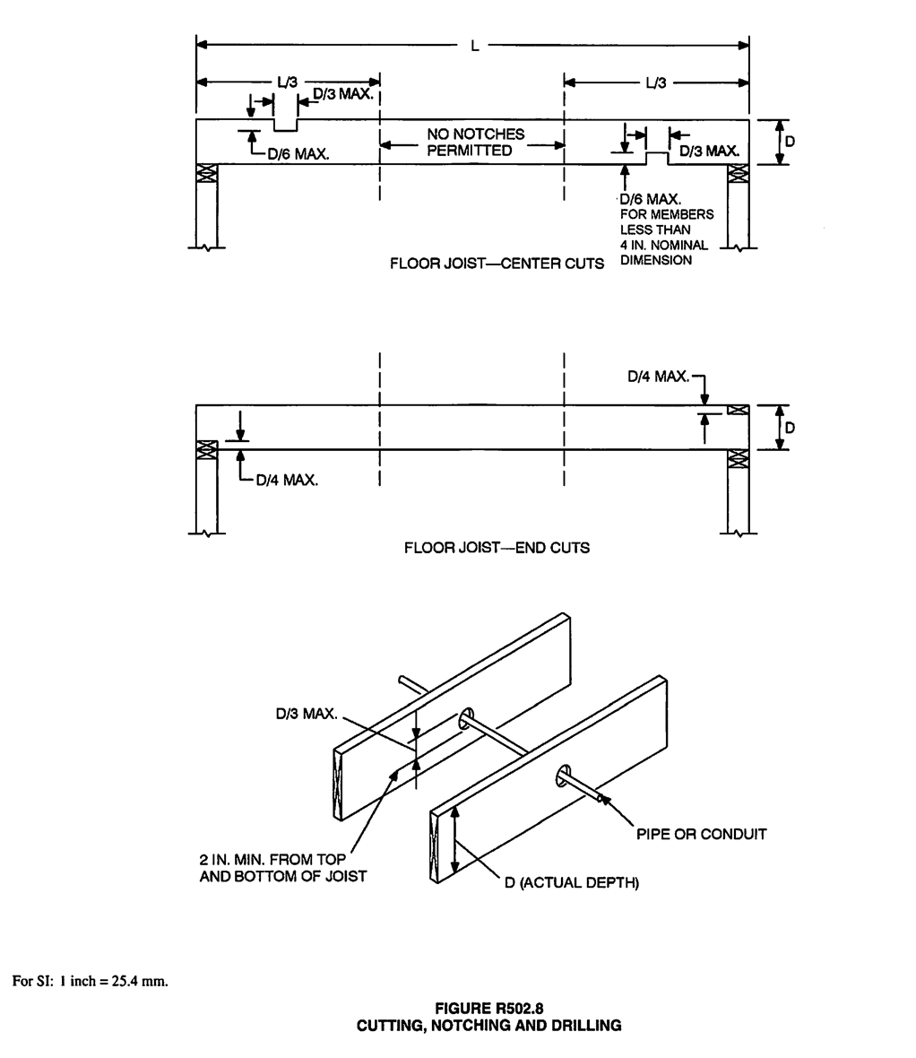

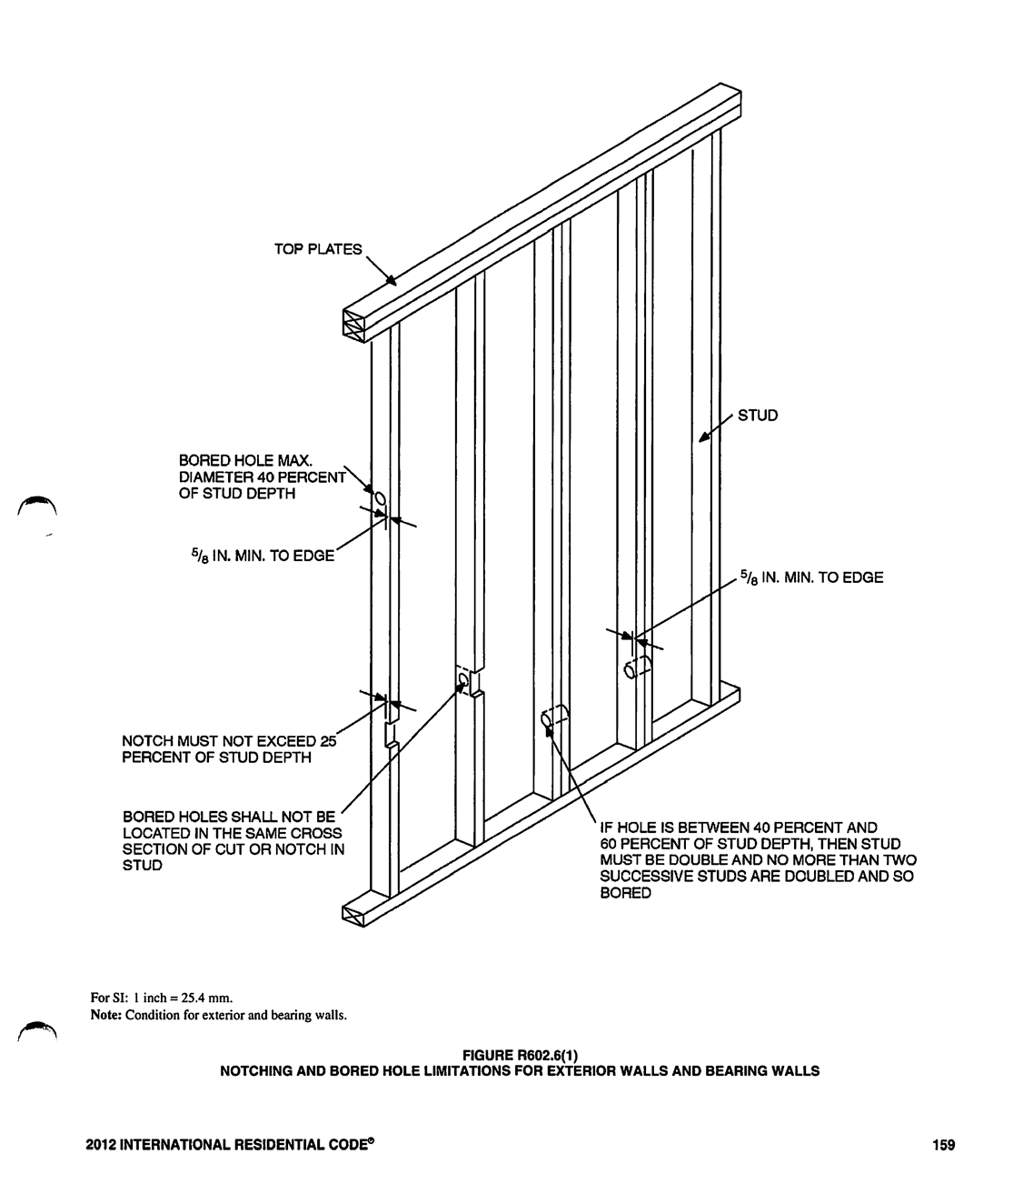

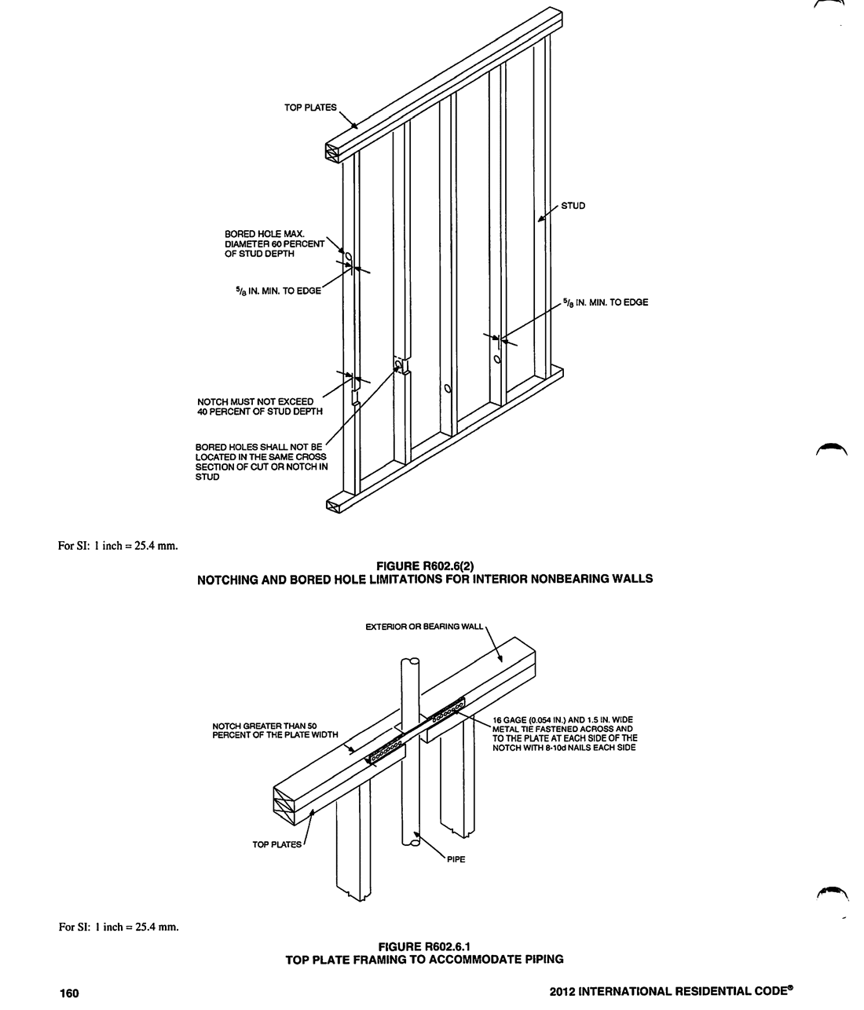

Water Distribution

Water distribution lines shall be tested at time of Rough‐In Inspection with water at operating pressure, or for pipes other than plastic pipe, a 50 psi air test. Air testing of plastic pipe is not allowed. (P2503.2) (P2503.7) This department has contacted ICC for a ruling on air testing PEX, and ICC ruled that it is a plastic pipe and therefore cannot be tested with air.
- Pipes are to be protected with shield plates that extend not less than 2” above sole plates and below top plates, when the pipe is located within 1‐1/2”of the face of the stud. (P2603.1)
- Pipes are to be properly supported to ensure alignment, and allow for expansion and contraction. (P2605.1)
- Water hammer arrestors shall be installed at clothes washers, dishwashers, and ice makers. The water hammer arrestor needs to be installed according to manufacturer’s instructions, not exceeding the maximum distance from the outlet served (6’ max distance is common, but check manufacturer’s instructions). (P2903.5)
- A shutoff valve is required on each plumbing fixture other than bathtubs and showers in one and two family dwellings. (IPC606.2)
- For automatic‐circulating hot water and heat‐traced systems, piping shall be insulated to at least R‐2. (IECC403.4)
- Hot and cold water lines should be separated according to manufacturer’s installation instructions to prevent heat exchange and the formation of condensation on the lines.
- Hose bibs are required to be frost‐proof and have vacuum breakers (P2903.10)

Water Heater
- Water heater must be equipped with an expansion tank. (P2903.4)
- A shut off valve is required on the cold side of the water heater.
- Water heater must be installed in a pan when installed in a location where leakage can cause damage to the interior surface. The pan drain must be plumbed to terminate over an approved indirect waste receptor or to the exterior of the building. (P2801.5)
- Water heaters having an ignition source shall be elevated such that the source of ignition is not less than 18” above the garage floor. Exception: Elevation of the ignition source is not required for appliances that are listed as flammable vapor ignition resistant.
- The temperature and pressure relief valve shall be plumbed to terminate no more than 6” above the floor, drain, or pan.

