
CITY OF CLEVELAND, TN DEVELOPMENT AND ENGINEERING RESIDENTIAL INSPECTION CHECKLIST

Please note: This list is not inclusive of all items that may require inspection. Failure to be ready for a requested inspection may result in a re‐inspection fee. In a Special Flood Hazard Area, all provisions of the municipal code and Flood‐Resistant construction must be followed.

FOOTINGS:
REQUIREMENT AND CODE SECTION OR REFERENCE
Contact the Development and Engineering office for footing specifications within a flood zone.

- Job address is posted in a visible location. (IRC R319.1)
- Sanitary facilities for workers on site. (IBC 3305.1) (IPC 311.1)
- Construction exit is installed and all required erosion control measures are in place.
- Building setbacks and location match approved plot plan/site plan. (IRC R106.2)
- Footing dug to width and depth acceptable by Standard Operating Procedures or copy of report for soils testing required, unless engineered drawings submitted to show otherwise. The City of Cleveland Standard Operating Procedures allow for no less than 12” deep supported on undisturbed natural soils or engineered fill, minimum 8” concrete depth, 18” – 24” wide with two runs #4 rebar (minimum) seated to provide 3” cover. Single Family Residential can be built on plain concrete footings if soil testing proves rebar is not needed. (IRC R403.1) (IBC 1809.7)
- Check footing for loose material, water, debris, mud, organic material and expansive soils. If fill material is on site, a copy of the soil report must be made available for the inspector. (IRC Table R405.1)
- Steel properly lapped, supported, correct size and free from rust, dirt or debris. Minimum size for residential is 2 runs #4 rebar, unless otherwise engineered. Laps should be 20” to 30” with two ties per lap. (IRC R404.1.3.5.4) (R611.5.4(1).
- Rebar at all corners to be field bent.
- Footings are level or stepped if the ground slopes more than 1 foot in 10 feet. Bulkheads are installed. (IRC R403.1.5)
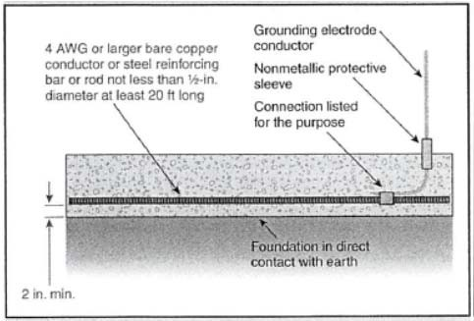
- Footings are designed to project beyond the face of the foundation wall at least 2 inches, but not more than the thickness of the footing. (IRC R403.1.1)
- Ground rod installed (if required). Rebar is not an acceptable material for the grounding rod, unless the grounding rod is entirely interior to the building.

